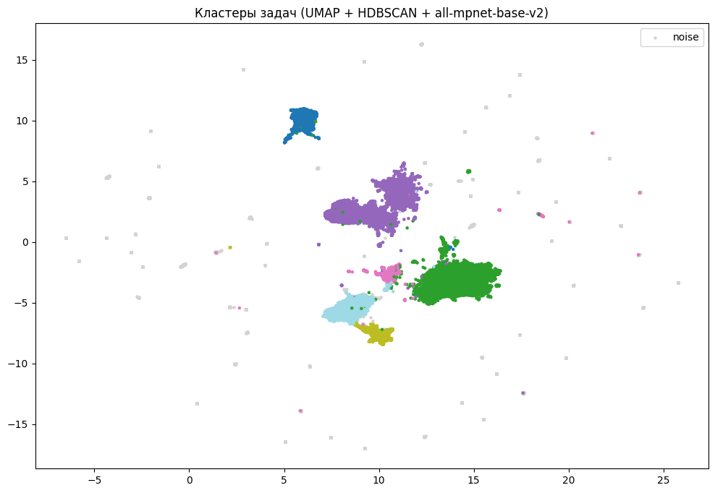
cluster_hdbscan
1 17918
2 16641
5 6821
-1 6628
0 5534
4 3326
3 1785
Name: count, dtype: int64

